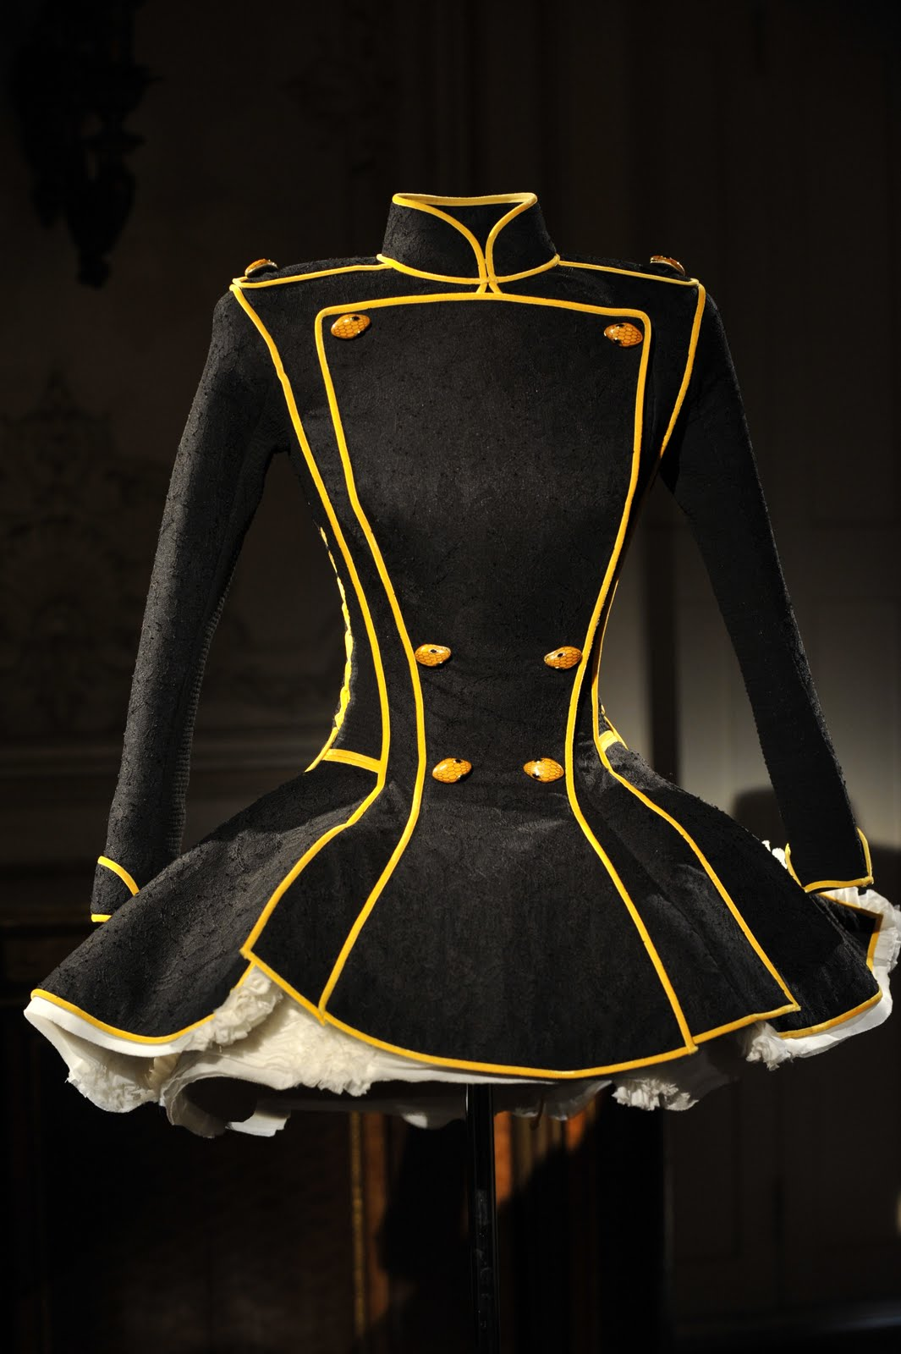
Wireless-Controlled Animated Accent-Lighted Dress Costume
- 8 channels of EL-wire lighting circuits for custom animations
- Self-contained, powered from 8 standard AA batteries
- Wireless control from master station with all costumes in sync
- Electronics per costume cost: $200
- Electronics for master station: $60
- Upgradeable to include LED accent lighting

Components:
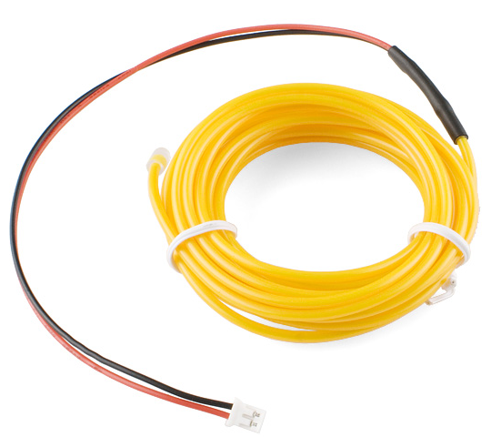
Bright Yellow EL Wire
- Up to 45 feet of continuous lit channels, 80 feet total in sewn circuits
- Bright contrast against black fabric, even in lit areas, amazing in darkness

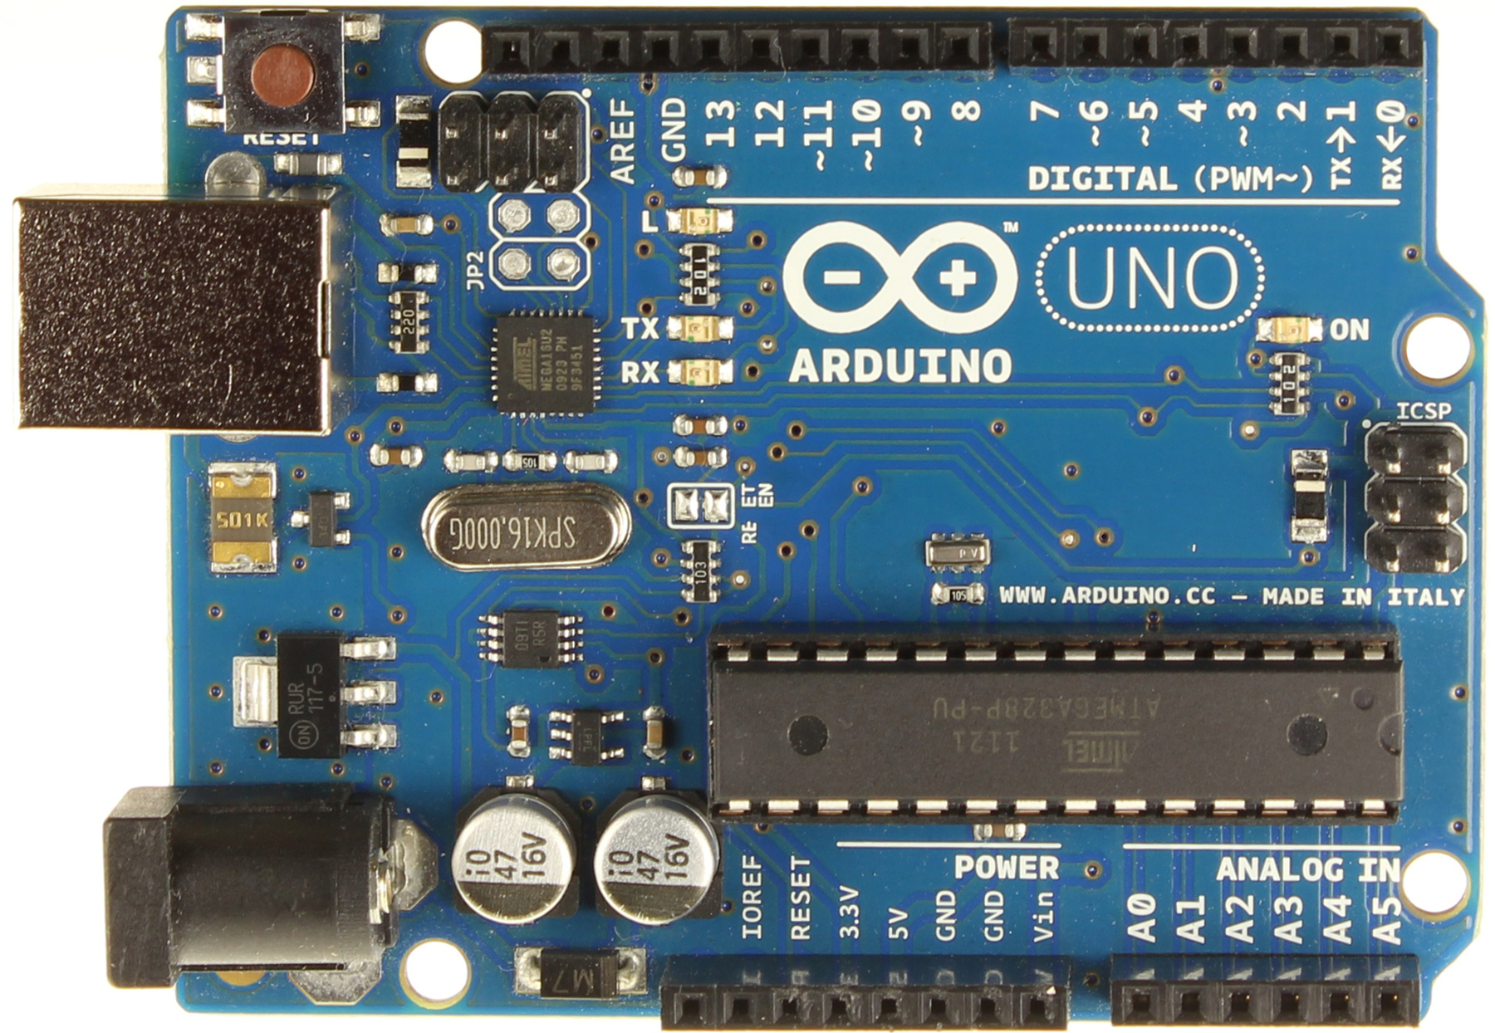
Arduino Microprocessor “Brain”
Amtel microprocessor in “Arduino” platform to interface between wireless module and EL driver board.

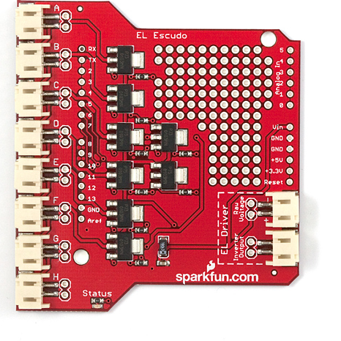
Sparkfun EL Driver Board
Sparkfun branded Arduino “Shield” to drive 8 EL-wire circuits.

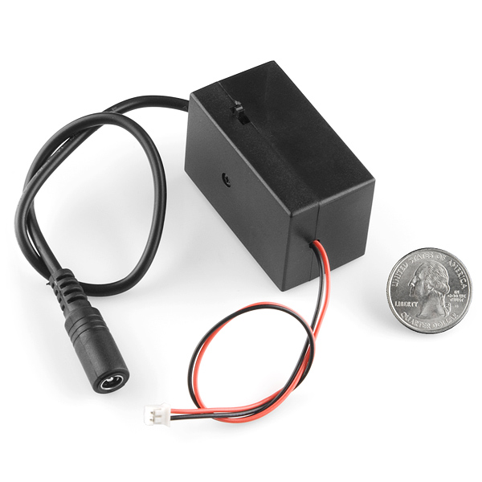
DC/AC Inverter for EL Wire
Battery 12-volt DC to EL-Wire’s required 100-volt AC inverter device.

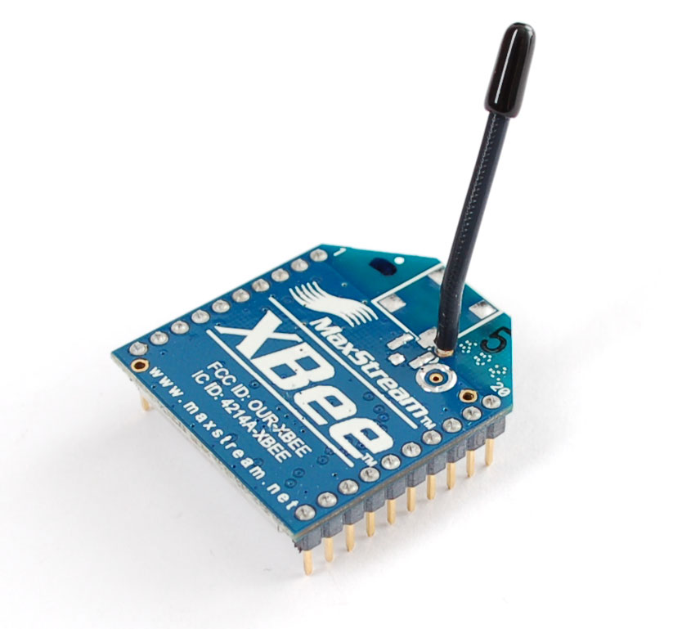
“XBee” Wireless Radio Component
XBee micro-radio for show control and sync between multiple costumes.

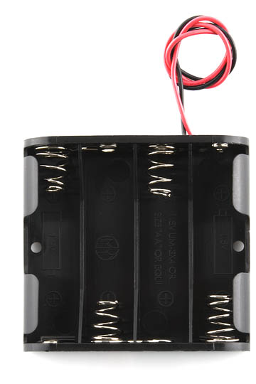
Two 4-AA Battery Compartments
12-volt power achieved from two 4xAA battery holders, distributed for wearing comfort.

